**Activity 4**

**Create Employee table and then answer the following questions:**

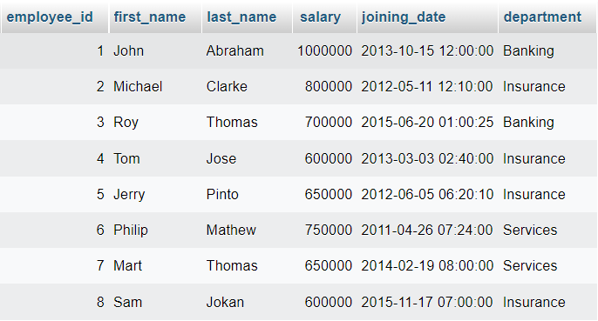

1. **Get all employee details from the employee table.**
2. **Get First_Name,Last_Name from employee table.**
3. **Get First_Name from employee table using alias name “Employee Name”.**
4. **Get unique department from employee table.**
5. **Get all employee details from the employee table order by First_Name descending.**
6. **Get all employee details from the employee table order by First_Name Ascending and Salary descending.**
7. **Get employee details from employee table whose employee name is “John”.**
8. **Get employee details from employee table whose Salary between 600000 and 700000 (6000000 & 700000 included).**
9. **For each department in employee table get total salary order by total salary descending.**
10. **For each department in employee table Get department name, number of employees in a department, department total salary.**
11. **Get all employees data who earn lowest salary.**
12. **Get all employees their names start with J and consist at least of 4 letters.**

Submit folder contain screen shots for the queries after 'go' and screen shots for the table result from each query.